*Eleusine coracana*

**Introduction**

*Eleusine coracana*, also known as finger millet, is a common grain crop, native to Ethiopia and Uganda. It’s commonly grown in southeast Africa and India. Reasons for its popularity are its drought resistance, tolerance to high elevations and long potential storage times. Fun fact: despite its African origin, the oldest archeological evidence for *E. coracana’s* presence in India has been dated to 1800 BCE. One wonders what patent rights applied back then. For

**Methodology**

For the settings used in Maxent, refer to the manual provided with the practical.

Variables were discarded if they correlated closely with one another. First, variables with multiple correlates were discarded. Of the remaining single correlates, precipitation of the warmest quarter was discarded in favour of precipitation of the wettest month (bio13), and precipitation of driest quarter in favour of precipitation seasonality (bio15). It was reasoned that maximum rainfall and seasonality would be more important for a drought-resistant species restriction in range. Additionally, a monthly variable combined with a quarterly variable might lead to overlap between the two. The remaining three variables were mean diurnal range (bio2), maximum temperature of warmest month (bio5) and mean temperature of wettest quarter (bio8).

**Model Output**

Using the maxent data in R, a number of visualizations could be generated (see figures 1, 2, 3). Note the different vertical axis, which appears to be the result of an unknown software problem.

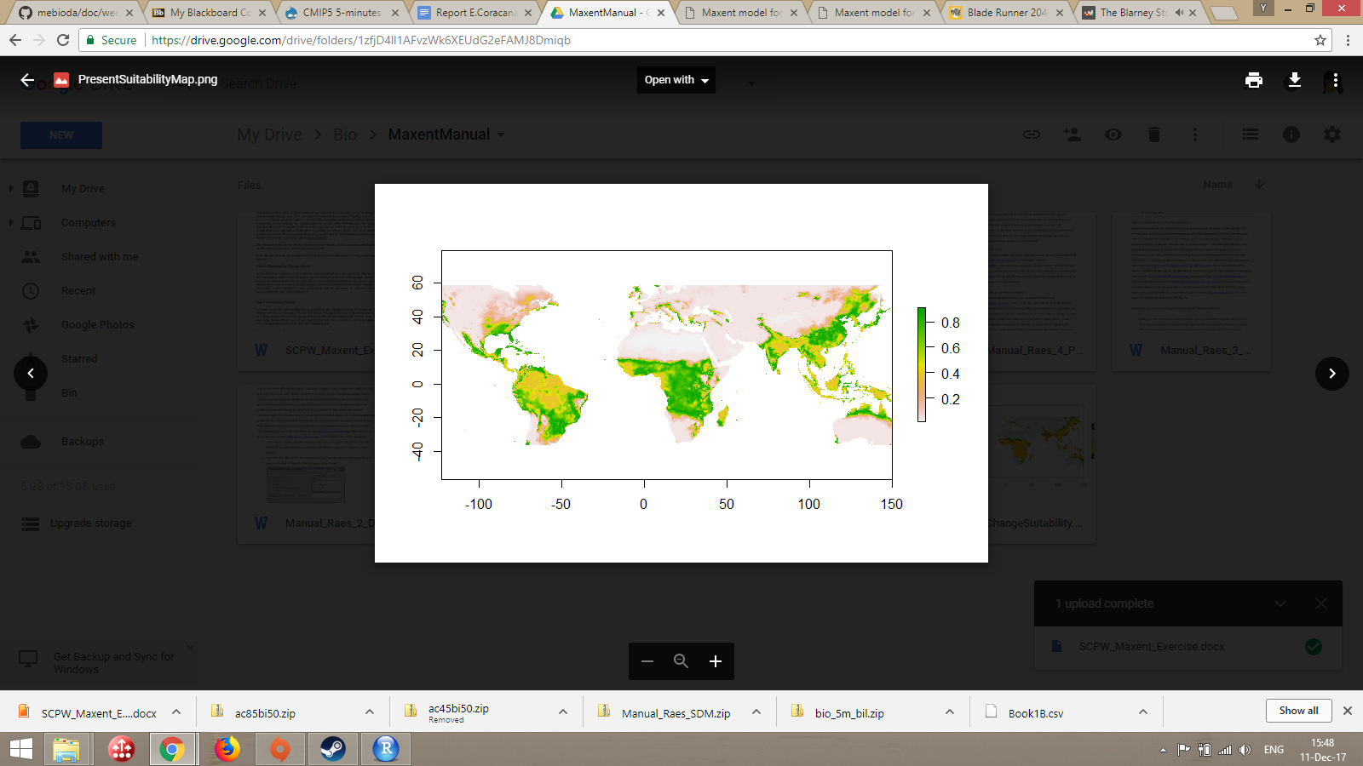

*Figure 1: Current habitat suitability modelled with worldclim data for E. coracana. White shows completely unsuitable areas, green extremely suitable areas.*

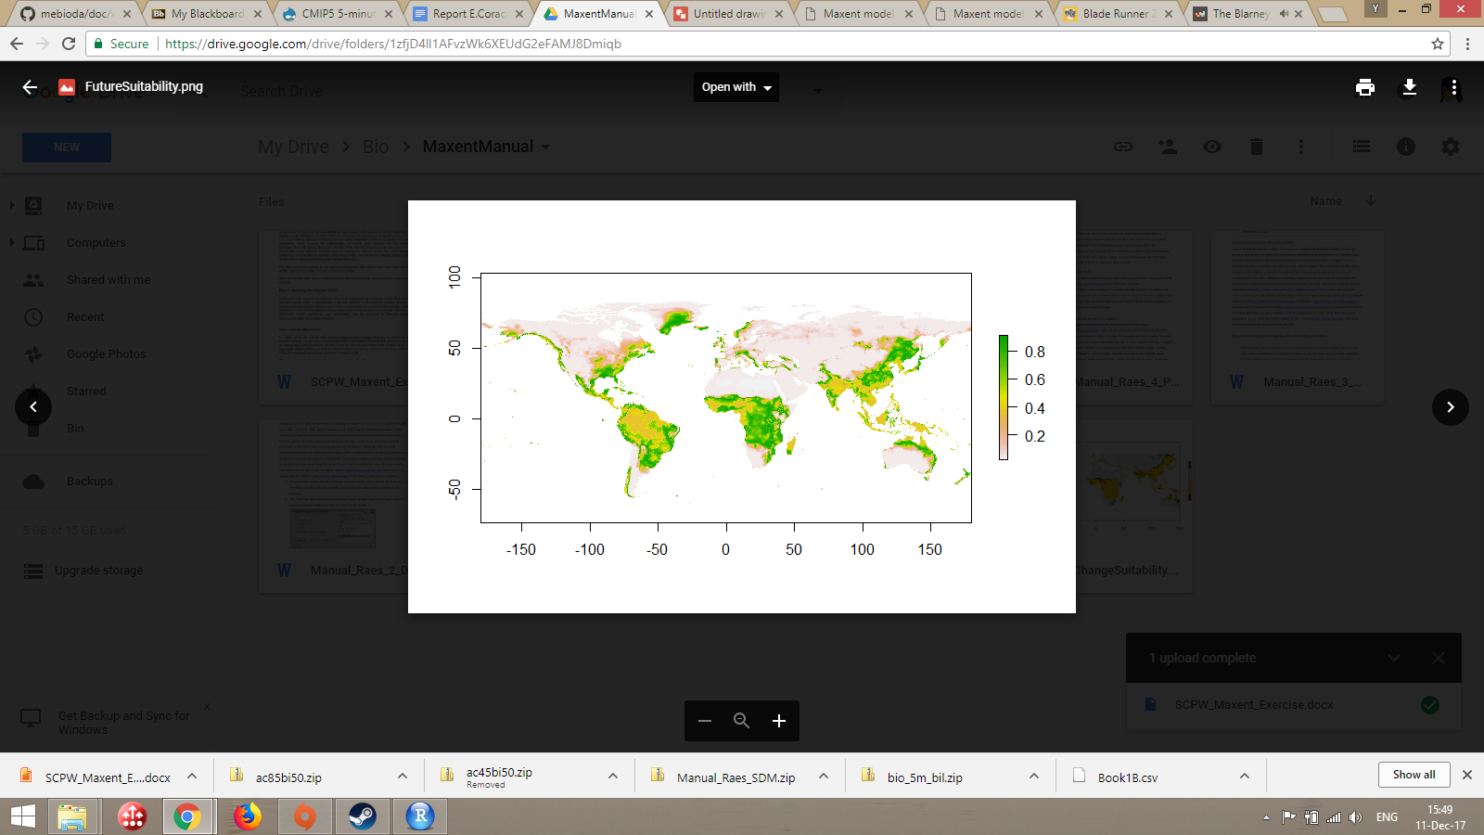

*Figure 2: Future habitat suitability modelled with worldclim data for E. coracana. White shows completely unsuitable areas, green extremely suitable areas. Data retrieved was for ACCES1-0 model, type rcp45 bi.*

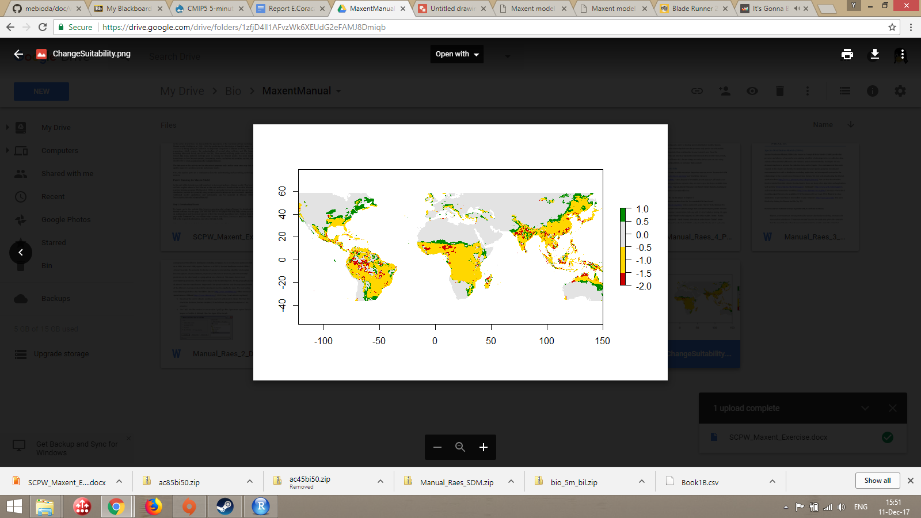

*Figure 3: Modelled changes in habitat suitability for E. coracana. Green signifies currently unsuitable areas predicted to become suitable. Yellow indicates no change in suitability. Red areas are predicted to become less suitable as habitat in the future.*

Model performance was estimated using an AUC (see figure 4). The shape and output data mean the model appears to be a decent fit, as it explains the input data at a rather higher level than a random prediction (AUC=0.789 rather than 0.5). It is unclear if examining residual plots or statistical power would give any further indication of the actual fit in this test.

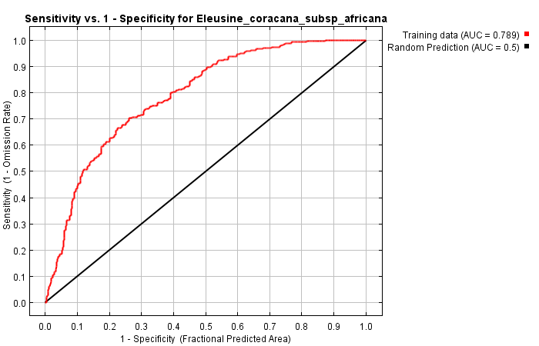

*Figure 4: AUC for E. coracana*

The main -almost exclusively- contributing variable in the model was precipitation of wettest month (see table 1). An explanation would be that, while *E. coracana* is known as a drought-resistant plant, it depends on short periods of sufficient precipitation for growth or survival. This would result in reduced dependence on temperature, diurnal length and precipitation variations compared to precipitation in the wettest month. This assumes a non-biased distribution of *E. coracana*, which is not the actual case (see below).

|  |  |  |
| --- | --- | --- |
| **Variable** | **Percent contribution** | **Permutation importance** |
| precipitation of wettest month | 97.8 | 81.9 |
| precipitation seasonality | 1.8 | 10.4 |
| mean diurnal range | 0.3 | 7 |
| maximum temperature of warmest month | 0.1 | 0.2 |
| mean temperature of wettest quarter | 0 | 0.5 |

*Table 1: Contributions of variable to generated model by percentage contribution, with additional listing of permutation importance. Note the extremely large share contributed by variable bio13.*

**Response to Future Scenario**

The model predicts a number of changes in suitable habitat range for *E. coracana* under the ACCES1-0 model, type rcp45 bi (see figures 4 and 5). While the majority of its currently modelled range appears unaltered, its suitable habitat range seems to extend in both northern and southern directions. A number of ‘islands’ within its current range appear to form, where suitability is modelled to go down under the used climate model.

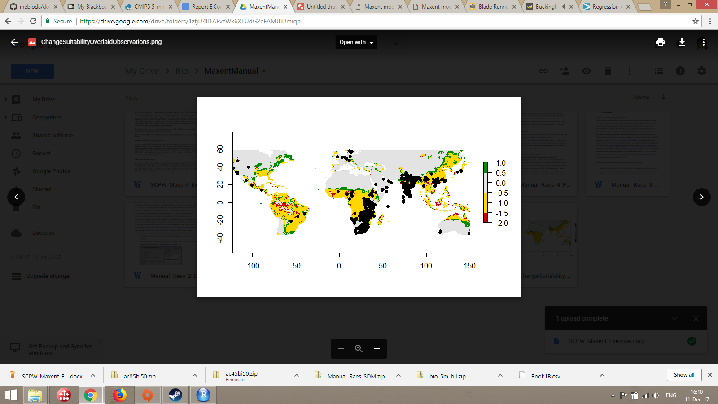

*Figure 5: Modelled changes in habitat suitability for E. coracana. Green signifies currently unsuitable areas predicted to become suitable. Yellow indicates no change in suitability. Red areas are predicted to become less suitable as habitat in the future. Black dots indicate occurrence data used to construct the model.*

**Biological Interpretation**

While this model might have interesting implications for agricultural use, it depends on a non-biased distribution of the modelled species. Since *Eleusine coracana* is a major food crop, the majority of its occurrences are planted- in areas whose suitability might be managed, for example by using (artificial) fertilizers and irrigation. While climate change might very well result in a shift in areas suited for cultivation, I would argue not to rely on the above approach due to this bias. One would have to supplement it with at the very least controlled studies on important growth factors, as well as agricultural practices used in cultivating this species. Some of the latter may be easier or harder to implement in the potential future range of the species.

A note on the apparent future reduction in suitable range occurring in now-suitable areas: this might be the result of variables currently unknown on earth, which forces the model to extrapolate, possibly erroneously. From the European Commission’s webpage on modelling climate impacts on crops and pests: “Unfortunately, projecting geographic distribution of this ecological niche into the future – using data from climate simulations – cannot take account of inter-species interactions or responses to conditions which do not yet exist within the species’ current geographical range.”

**Sources**

Handout: “Exercise: Model your choses species’ habitat suitability under present and future climate conditions”

<https://ec.europa.eu/programmes/horizon2020/en/news/modelling-climate-impacts-crops-and-pests>